H.T No
Regulations:
A17

Sreenidhi Institute of Science and Technology
(An Autonomous Institution)
Code No: 6C727 Date: 01-Sept-2021 (FN)

B.Tech IV-Year I- Semester External Examination, Aug/Sept - 2021 (Supplementary)
DIGITAL DESIGN THROUGH VERILOG (ECE)

Time: 3 Hours Max.Marks:75

Note: a) No additional answer sheets will be provided.
b) All sub-parts of a question must be answered at one place only, otherwise it will not be valued.
c) Missing data can be assumed suitably.

ANSWER ANY 5 OUT OF 8 QUESTIONS. EACH QUESTION CARRIES 15 MARKS.

Bloom's Cognitive Levels of Learning (BCLL)

Remember | L1 | Apply | L3 | Evaluate | L5
Understand | L2 | Analyze | L4 | Create | L6

 |  |  | BCLL | CO(s) | Marks
1. | a) | Explain the ASIC design flow briefly. | L2 | CO1 | [8M]
 | b) | Explain the activities involved in Physical Design Process. | L2 | CO1 | [7M]
2. | a) | Explain the blocking and non-blocking statements in Verilog with suitable example. | L2 | CO2 | [8M]
 | b) | Write the 2:4 Priority Encoder Verilog HDL code. | L1 | CO2 | [7M]
3. | a) | Design a 4-bit parallel adder and write a test bench to verify its functionality. | L6 | CO3 | [8M]
 | b) | Describe Gate Delays. Write the Verilog HDL code for following schematic diagram and draw the timing diagram for following two cases.  Case 1: Assume any one of the input is “0” of “g2” instance and assume input “c1” is always “High”  Case 2: Assume any one of the input is “0” of “g1” instance and assume input “c2” is always “High”  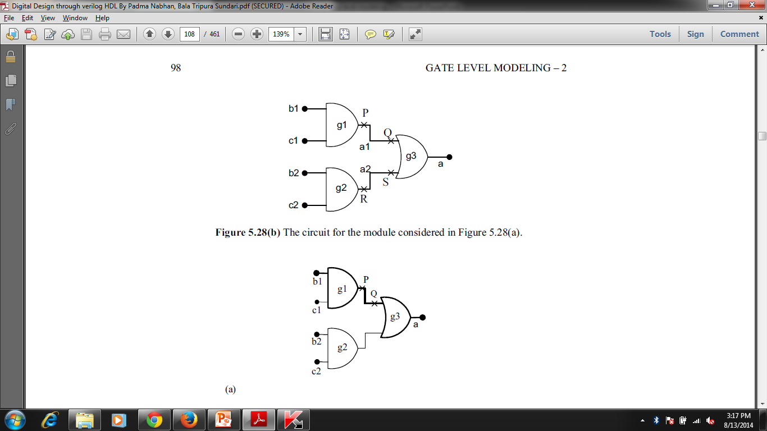  Assume  i Rise Time Delay is “2” and Fall Time Delay is “1” for wires a1,a2;  ii Rise Time Delay is “3” and Fall Time Delay is “4” for g1;  iii Rise Time Delay is “5” and Fall Time Delay is “6” for g2;  iv Rise Time Delay is “8” and Fall Time Delay is “7” for g3; | L1 | CO3 | [7M]
4. | a) | Apply User Defined Primitive for JK Flip Flop. | L3 | CO4 | [8M]
 | b) | What is contention resolution and explain how it can be eliminated with suitable example. | L2 | CO4 | [7M]
5. | a) | Describe combinational testing with examples. | L1 | CO5 | [8M]
 | b) | Explain the assert-one-hot monitor with the help of an example. | L2 | CO5 | [7M]
6. |  | Design a vending machine in Verilog HDL. | L6 | CO6 | [15M]
7. | a) | Explain the terms Scalars and Vectors. | L2 | CO1 | [5M]
 | b) | Write Verilog HDL source code for a data level description of 4 to 1 multiplexer circuit. | L1 | CO2 | [5M]
 | c) | Discuss the Time Delays associated with gates. | L2 | CO3 | [5M]
8. | a) | Distinguish Tasks and Function with examples. | L2 | CO4 | [5M]
 | b) | Describe test bench and mention few techniques. | L1 | CO5 | [5M]
 | c) | Illustrate the ASM chart for Dice game controller. | L4 | CO6 | [5M]
-- 00 -- 00 –

